**PREGNANCY RISK**

**How being a fat mum ‘could shorten your baby’s life by 17 YEARS’**

High body mass index in mums pre-pregnancy is linked to shorter telomere length – a key marker for biological age

**BY LIZZIE PARRY**

18th October 2016, 1:00 am

* [Click to share on Twitter (Opens in new window)](https://www.thesun.co.uk/living/1995364/how-being-a-fat-mum-increases-your-babys-risk-of-premature-ageing-and-chronic-disease/?share=twitter&nb=1)
* [Click to share on Facebook (Opens in new window)](https://www.thesun.co.uk/living/1995364/how-being-a-fat-mum-increases-your-babys-risk-of-premature-ageing-and-chronic-disease/?share=facebook&nb=1)

**0W**

COMMENT

**MUMS-TO-BE who are obese before conception are more likely to have babies at risk of premature ageing, experts warned today.**

High body mass index in mums [pre-pregnancy](https://www.thesun.co.uk/topic/pregnancy/) is linked to shorter telomere length – a key marker for biological age – in newborns, new research has shown.

[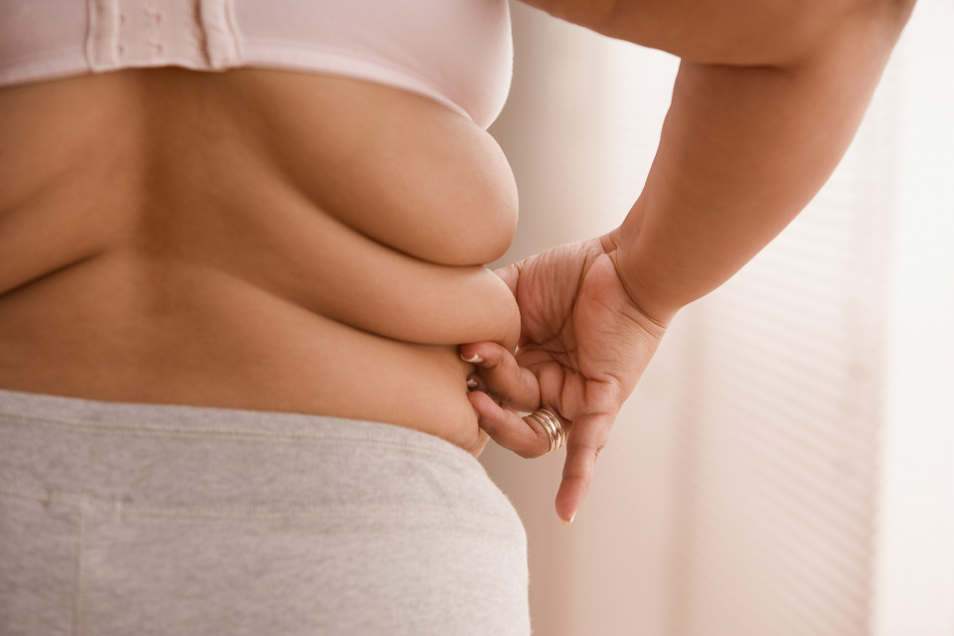](https://www.thesun.co.uk/living/1995364/how-being-a-fat-mum-increases-your-babys-risk-of-premature-ageing-and-chronic-disease/)

GETTY IMAGES

[2](https://www.thesun.co.uk/living/1995364/how-being-a-fat-mum-increases-your-babys-risk-of-premature-ageing-and-chronic-disease/)

Being obese prior to becoming pregnant increases the risk a woman’s baby will age prematurely, and increases their risk of chronic disease in adulthood

The evidence from Hasselt University in Belgium is the first to show a strong link between a mum’s BMI and [obesity](https://www.thesun.co.uk/topic/obesity/) and telomere length in newborns.

Telomeres are structures at the end of chromosomes, which are vital in maintaining the stability of a person’s genome – and protect chromosomes from degrading over time.

Telomere length is directly linked to the number of times a cell can divide in its lifetime.



–– ADVERTISEMENT ––



https://video.unrulymedia.com/native/in-art-soundanimation-icon-41x48.gif

Therefore, the longer a telomere is, the more cells can divide – providing a link between telomere length and biological age.

RELATED STORIES

[[](https://www.thesun.co.uk/living/1952141/podgy-parents-who-both-piled-on-the-pounds-during-pregnancy-have-lost-13-stone-by-ditching-their-8000-calorie-diet/)](https://www.thesun.co.uk/living/1952141/podgy-parents-who-both-piled-on-the-pounds-during-pregnancy-have-lost-13-stone-by-ditching-their-8000-calorie-diet/)

**'WE'RE THE HAPPIEST WE'VE EVER BEEN'**

Podgy parents who piled on pregnancy pounds lost 13st by ditching 8,000 cal diet

[[](https://www.thesun.co.uk/living/1944409/breakthrough-as-scientists-discover-how-to-slow-down-the-ageing-process-raising-hopes-of-drug-treatments/)](https://www.thesun.co.uk/living/1944409/breakthrough-as-scientists-discover-how-to-slow-down-the-ageing-process-raising-hopes-of-drug-treatments/)

**ANTI-AGEING PILL?**

Breakthrough as scientists discover how to slow down the ageing process - raising hopes of drug treatments

[[](https://www.thesun.co.uk/living/1748430/it-boosts-weight-loss-helps-prevent-cancer-and-delays-ageing-7-reasons-to-swap-your-builders-for-a-green-tea/)](https://www.thesun.co.uk/living/1748430/it-boosts-weight-loss-helps-prevent-cancer-and-delays-ageing-7-reasons-to-swap-your-builders-for-a-green-tea/)

**GO GREEN**

It boosts weight loss, helps prevent cancer AND delays ageing... 7 reasons to swap your builders for a green tea

[[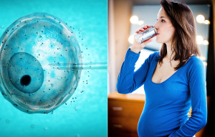](https://www.thesun.co.uk/living/1989207/diet-fizzy-drinks-could-slash-chances-of-getting-pregnant-during-ivf/)](https://www.thesun.co.uk/living/1989207/diet-fizzy-drinks-could-slash-chances-of-getting-pregnant-during-ivf/)

**NOT SO SWEET**

Diet fizzy drinks 'could slash chances of getting pregnant during IVF'

Past studies have shown links between telomere length and increased risk of adults developing [heart disease](https://www.thesun.co.uk/topic/heart-disease/), [type 2 diabetes](https://www.thesun.co.uk/living/1904258/what-is-type-2-diabetes-what-are-the-signs-to-watch-out-for-and-how-is-it-treated/) and early death.

But, research into the effect of telomere length on newborns is limited.

Professor Tim Nawrot, one of the authors of the new study, said: “Compared with newborns of mothers with a normal BMI, newborns of women with obesity are older on a molecular level, because shortened telomere lengths mean that their cells have shorter lifespans.

“So maintaining [a healthy BMI](https://www.thesun.co.uk/topic/weight-gain/)during a woman’s reproductive age may promote molecular longevity in the offspring.”

[](https://www.thesun.co.uk/living/1995364/how-being-a-fat-mum-increases-your-babys-risk-of-premature-ageing-and-chronic-disease/)

GETTY IMAGES

[2](https://www.thesun.co.uk/living/1995364/how-being-a-fat-mum-increases-your-babys-risk-of-premature-ageing-and-chronic-disease/)

High body mass index in mums pre-pregnancy is linked to shorter telomere length – a key marker for biological age – in newborns, new research has shown

Previous studies have shown people typically lose about 32.2 to 45.5 telomere base pairs every year of their adult lives.

The research team found that for each one-point increase in the mums’ BMI, telomeres in the babies were about 50 base pairs shorter.

This 50 base pair shortening of telomere length is the equivalent to the length people normally lose in 1.1 to 1.6 years of adult life.

**Maintaining a healthy BMI during a woman’s reproductive age may promote molecular longevity in the offspring**

**Professor Tim Nawrot, Hasselt University**

As a result, the researchers warn, babies of mums with higher BMIs are at greater risk of developing chronic diseases in their adult years.

That is after, experts accounted for other factors that could have an influence, including parents’ age at birth, socio-economic class, ethnicity, maternal smoking status, newborns’ gender or birth weight.

Professor Nawrot said: “Prior to our study, there was no evidence of an association between pre-pregnancy BMI and newborn telomere length, although meta-analyses suggest an association between BMI and telomere length in adults.

“Our results add to the growing body of evidence that high maternal BMI impacts fetal programming, which could lead to altered fetal development and later life diseases.

“The public health impact of our findings is considerable as in affluent societies about 30 per cent of women of reproductive age are overweight.”

To examine associations between maternal BMI and newborn telomere length, Professor Nawrot and his colleagues examined 743 mothers, who were 17 to 44 years of age, and their newborn babies.

Detailed information on maternal and paternal age, socioeconomic status, smoking status, parity, ethnicity and pregnancy complications was obtained by use of a questionnaire.

To measure average telomere lengths, umbilical cord blood was drawn immediately after delivery from all 743 mother-newborn pairs.

The researchers say that their study may be limited by lack of information on paternal BMI as previous research has described epigenetic effects of paternal weight on newborns.

The findings are published in the journal BMC Medicine.